**CS590BD Big Data Analysis**

**Lab3**

* **Firstly we generate a war from the project**

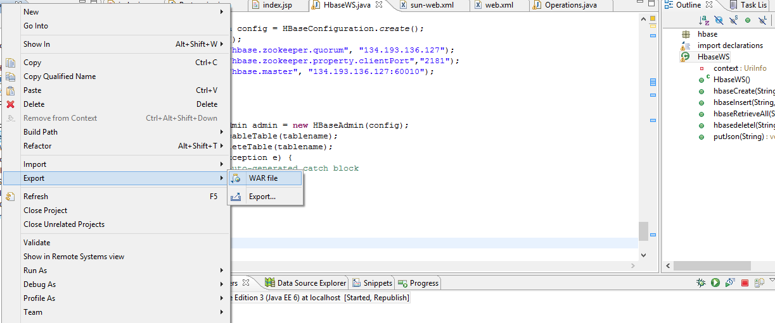

1. we have deployed our generated war file onto glassfish server.

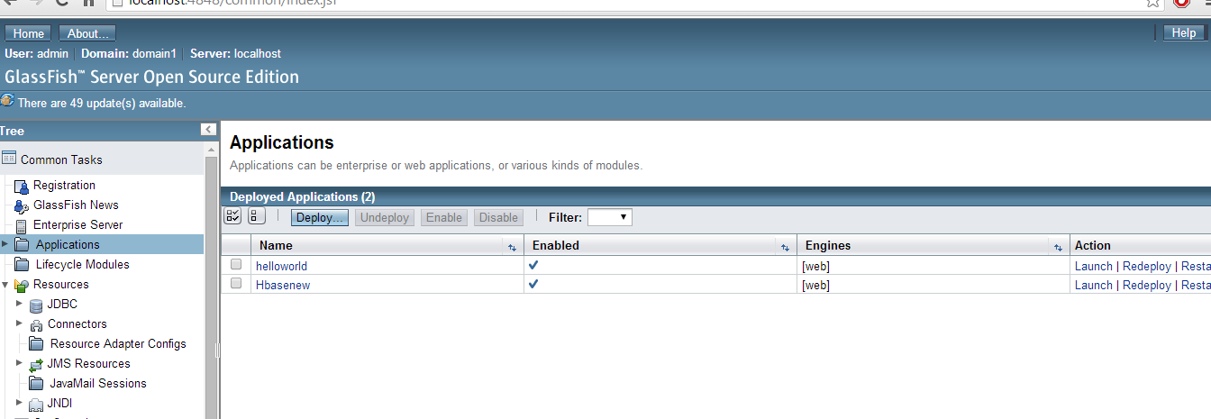

1. By running the URL ,based on method invocation tables will be created first ,

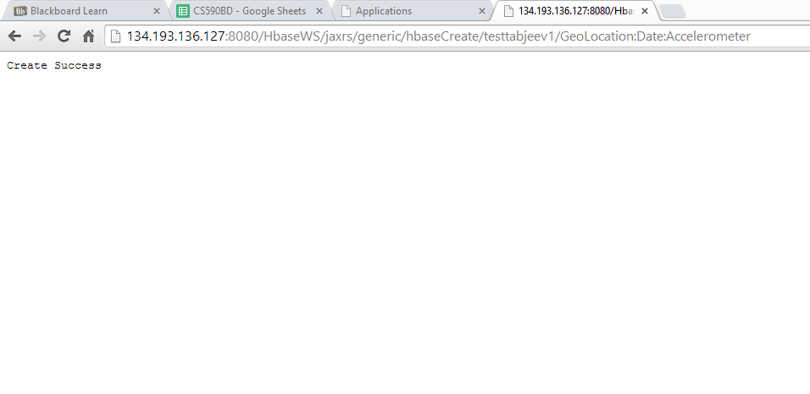

1. Insert the file (sensor.txt) into newly created database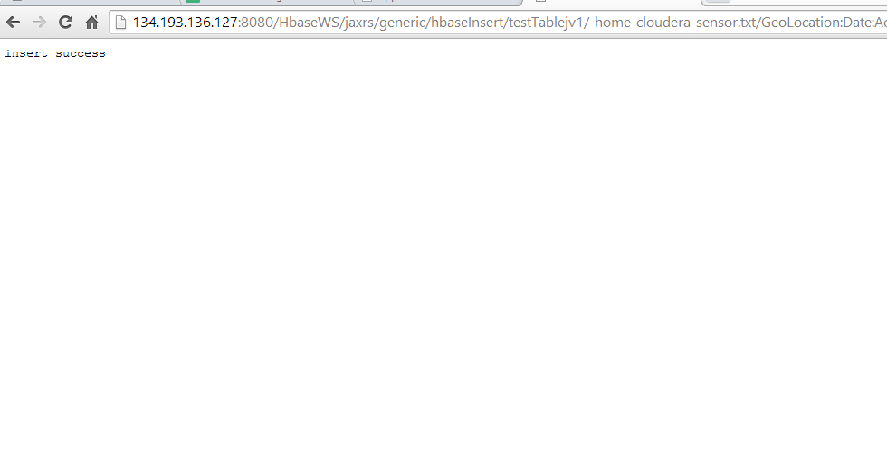
2. Retrieve the contents from the table

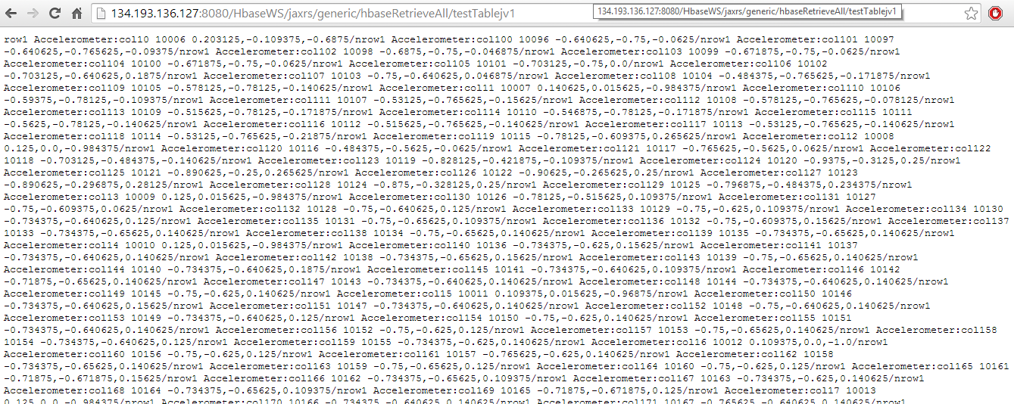

1. Delete the table.

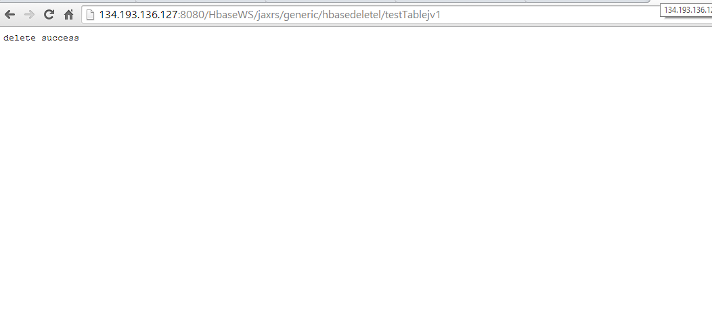

Above all methods are invoked, displayed using android Layout.

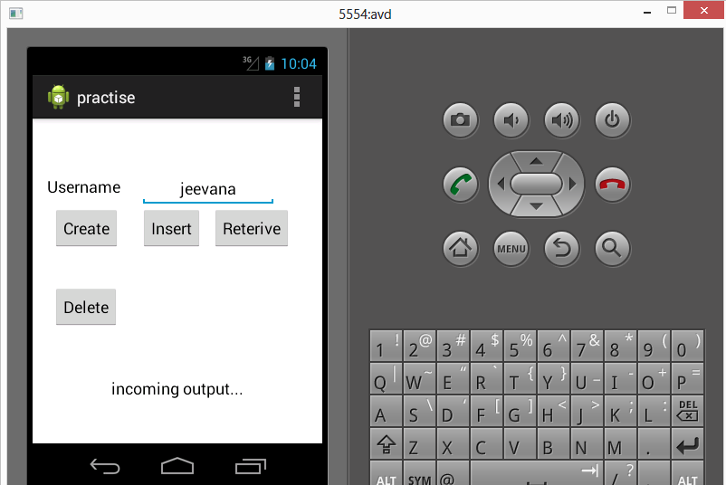

By clicking create push button

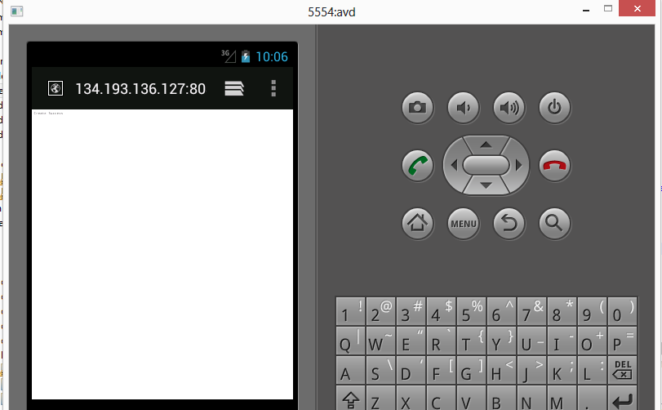

By clicking insert push button (sensor.txt file will be inserted)



By clicking retrieve push button data will be fetched

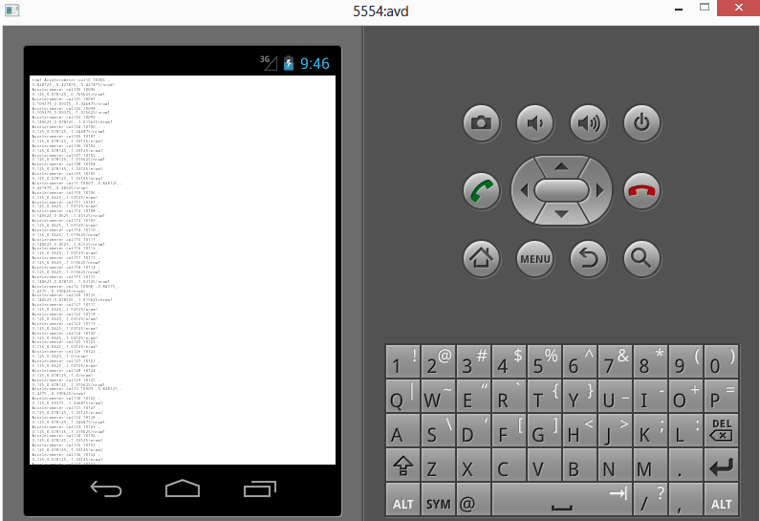

By clicking detele button table will be deleted from hbase

